Reinforcement Learning Assignment Report
Introduction
This report presents the results of a reinforcement learning assignment that includes two main parts: Q-Learning and Policy Iteration on the FrozenLake environment, and Deep Q-Learning on Atari Breakout. The experiments show how different RL algorithms perform and provide useful insights into how sensitive they are to hyperparameters and how they compare with each other.
Part 1: Q-Learning and Policy Iteration on Frozen Lake Environment
Environment Overview
The Frozen Lake environment is a classic grid-world problem with the following characteristics:
- State space: 16 discrete states (4×4 grid)
- Action space: 4 actions (Up, Down, Left, Right)
- Environment type: Stochastic (slippery surface)
- Objective: Navigate from start to goal while avoiding holes

Algorithm Implementation
Q-Learning Algorithm
The Q-Learning agent was implemented with the following key components:
- Q-table: 16×4 matrix initialized with zeros
- Epsilon-greedy policy: For exploration-exploitation balance
- Q-learning update rule: Q(s,a) ← Q(s,a) + α[r + γ max Q(s',a') - Q(s,a)]
Policy Iteration Algorithm
The Policy Iteration algorithm was implemented with:
- Policy evaluation: Iterative computation of value function
- Policy improvement: Greedy policy update based on value function
- Convergence criterion: θ = 1e-8 for value function stability
Hyperparameter Analysis
Learning Rate (α) Analysis
The learning rate (alpha) controls how much newly learned information overrides previously stored Q-values during training.
- Three values were tested: 0.05, 0.1, and 0.5

Results:
- Alpha = 0.05: Average Reward = 0.240 | Success Rate = 24.0%
- Alpha = 0.1: Average Reward = 0.000 | Success Rate = 0.0%
- Alpha = 0.5: Average Reward = 0.530 | Success Rate = 53.0%
Analysis:
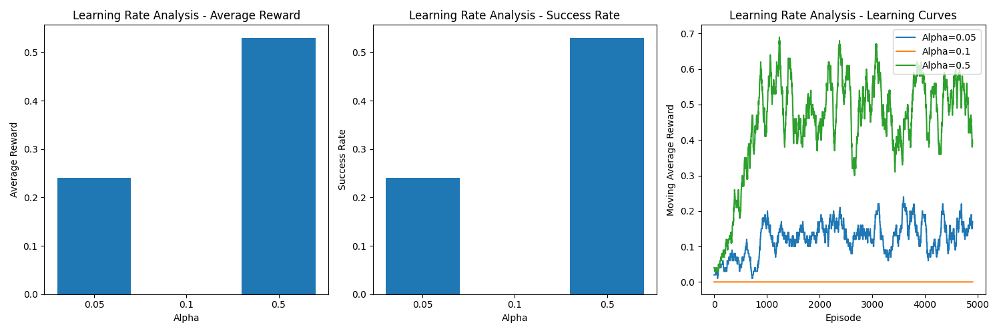
high learning rate (α=0.5) works best, achieving the highest reward and success. A medium rate (α=0.1) completely fails, showing the agent learned nothing. A low rate (α=0.05) learns slowly but ends up with a much lower final performance.
Discount Factor (γ) Analysis
Gamma controls how much the agent considers future rewards over immediate rewards during learning.
- Three values were tested: 0.8, 0.95, and 0.99
Results:
- Gamma = 0.8: Average Reward = 0.000 | Success Rate = 0.0%
- Gamma = 0.95: Average Reward = 0.740 | Success Rate = 74.0%
- Gamma = 0.99: Average Reward = 0.760 | Success Rate = 76.0%
Analysis:
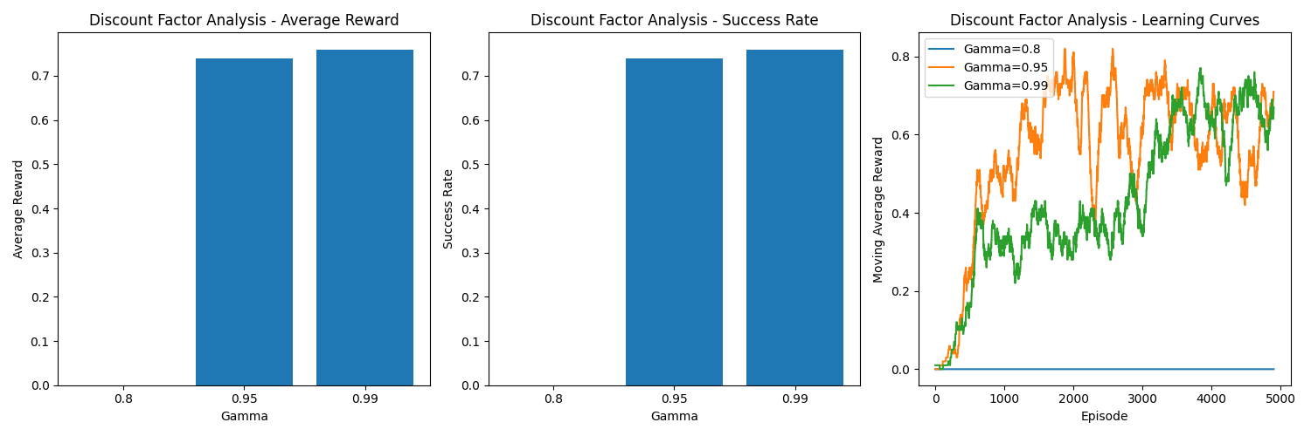
The results show that a long-term strategy is essential. The agent's performance was much better with higher discount factors (0.95, 0.99) that prioritize future goals. In contrast, using a low discount factor of γ=0.8 led to complete failure because it made the agent too short-sighted.
Exploration Rate (ε) Impact
Epsilon controls how often the agent explores new actions instead of exploiting known ones. A higher epsilon means more exploration at the start of training.
- Three values were tested: 0.1, 0.5, and 1.0
Results:
- Epsilon = 0.1: Average Reward = 0.000| Success Rate = 0.0%
- Epsilon = 0.5: Average Reward = 0.000| Success Rate = 0.0%
- Epsilon = 1.0: Average Reward = 0.720| Success Rate = 72.0%
Analysis:
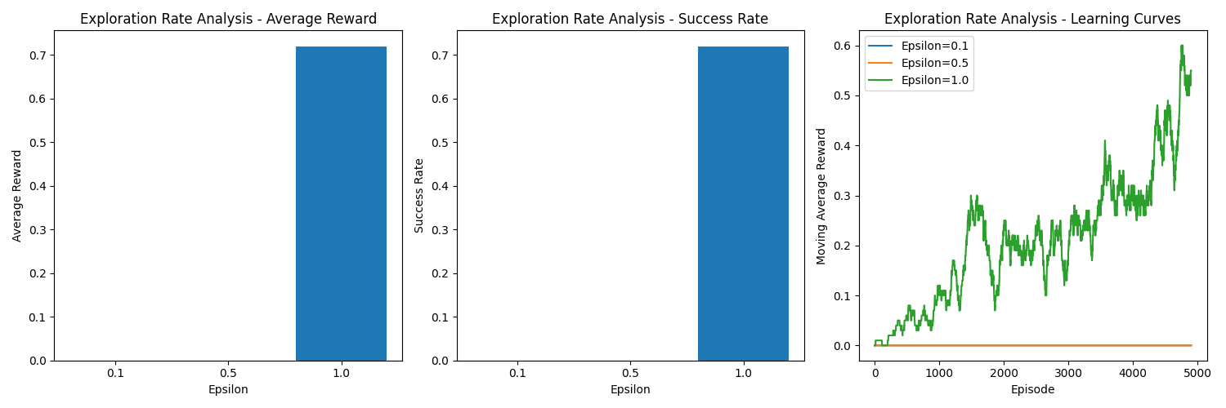
High initial exploration (ε=1.0) was crucial for learning an effective policy. Lower exploration rates failed completely, highlighting the importance of exploration in stochastic environments.
Experimental Results
Algorithm Comparison
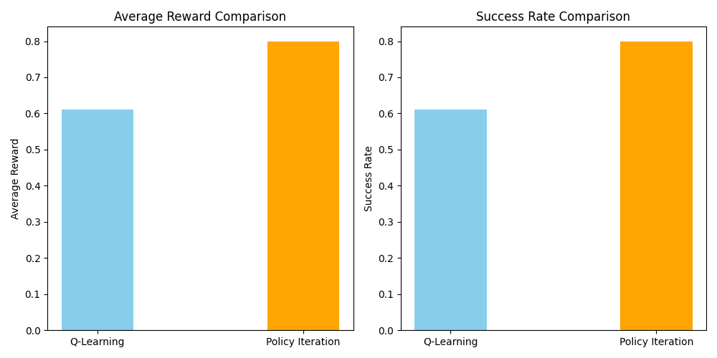
The comparison between Q-Learning and Policy Iteration revealed significant performance differences:
The performance of Q-Learning and Policy Iteration was compared in the FrozenLake environment. Q-Learning achieved an average reward of 0.610 with a success rate of 61.0%. In contrast, Policy Iteration performed better, reaching an average reward of 0.800 and a success rate of 80.0%.
Key Findings:
- Policy Iteration significantly outperformed Q-Learning with 31% higher success rate
- Policy Iteration converged to optimal policy more reliably
- Q-Learning showed more variability in performance across episodes
Learning Curve Analysis:
The learning curves revealed important insights about convergence patterns:
- Alpha=0.5: Showed steady improvement and stabilization around episode 1000
- Gamma=0.95/0.99: Demonstrated rapid initial learning followed by stable performance
- Epsilon=1.0: Exhibited gradual improvement throughout training with eventual convergence

Part 2: Deep Q-Learning on Atari Breakout
Environment and Implementation:
Atari Breakout Environment
- Environment: ALE/Breakout-v5
- Action space: 4 discrete actions
- Observation space: 210×160×3 RGB images
- Objective: Maximize score by breaking bricks with a paddle and ball
Deep Q-Network Architecture
The DQN implementation featured:
- Convolutional layers: 3 conv layers for feature extraction
Conv1: 32 filters, 8×8 kernel, stride 4
Conv2: 64 filters, 4×4 kernel, stride 2
Conv3: 64 filters, 3×3 kernel, stride 1
- Fully connected layers: 512 hidden units + output layer
- Frame preprocessing: 84×84 grayscale, 4-frame stacking
- Experience replay: 100,000 capacity buffer
- Target network: Updated every 1000 steps
Training Results
Performance Metrics
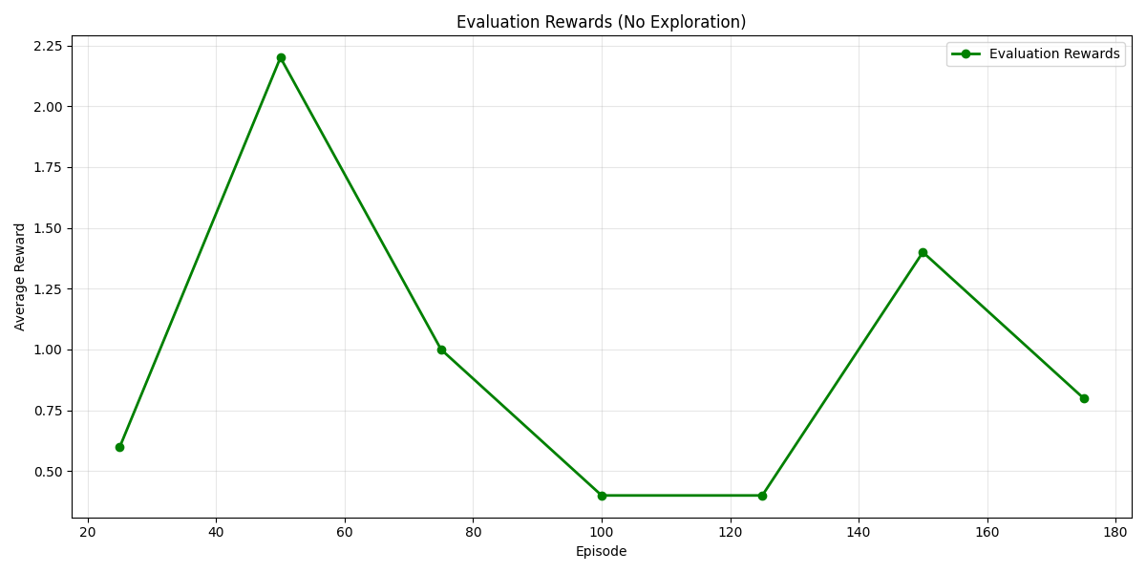
The DQN agent was trained for 200 episodes with the following final results:
- Average Training Reward (last 50 episodes): 1.50
- Final Evaluation Reward: 0.80
- Best Evaluation Reward: 2.20
- Training Device: CUDA (GPU acceleration)
Training Dynamics Analysis
Training Progress
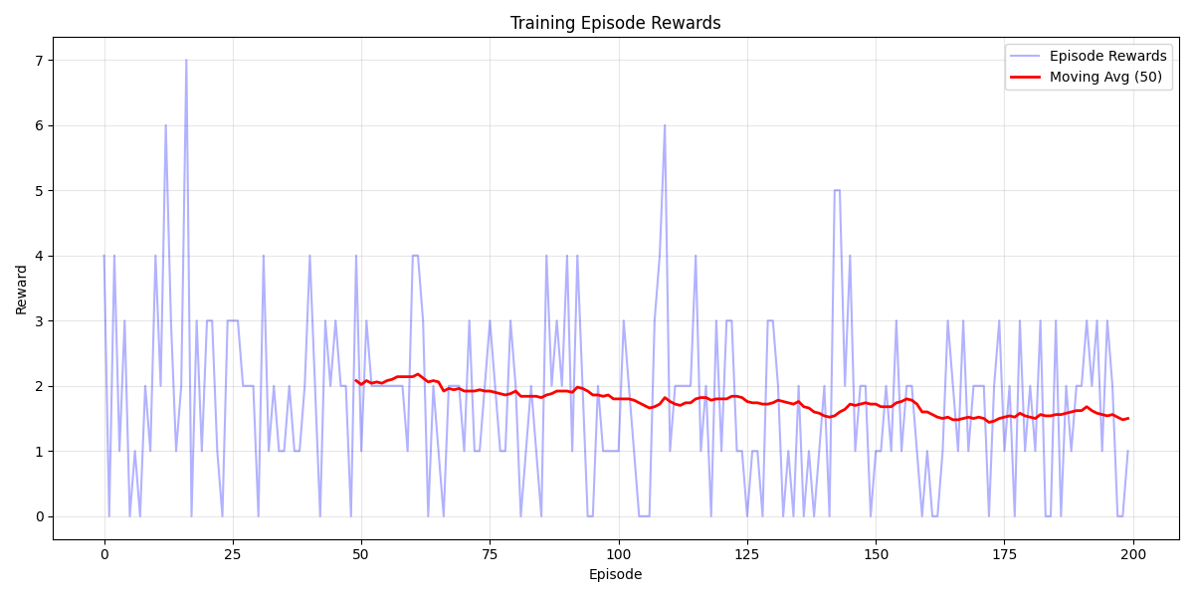
The training reward analysis revealed:
- Initial Learning: Rapid improvement in early episodes
- Peak Performance: Best evaluation reward of 2.20 at episode 50
- Stabilization: Performance stabilized around 1.5-2.0 reward range
- Final Convergence: Slight decline in later episodes, suggesting potential overfitting
Episode Length Patterns
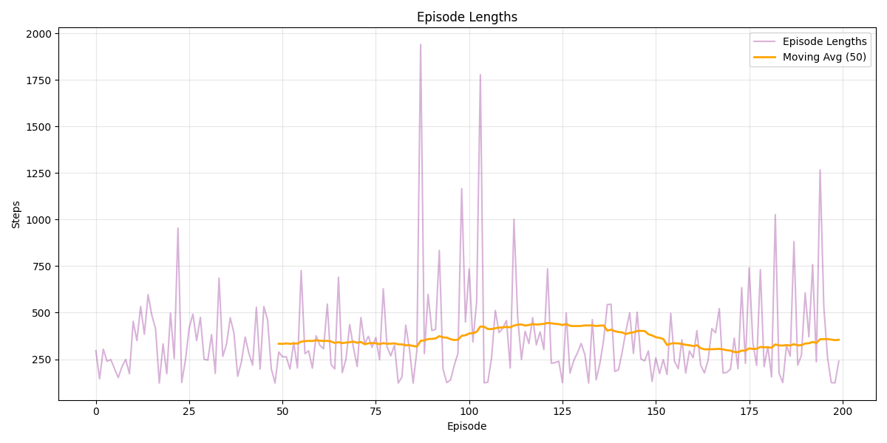
Episode length analysis showed:
- Average Length: ~350 steps with high variability
- Peak Episodes: Some episodes extended beyond 1500 steps
- Trend: Relatively stable episode lengths throughout training
Evaluation vs Training Performance
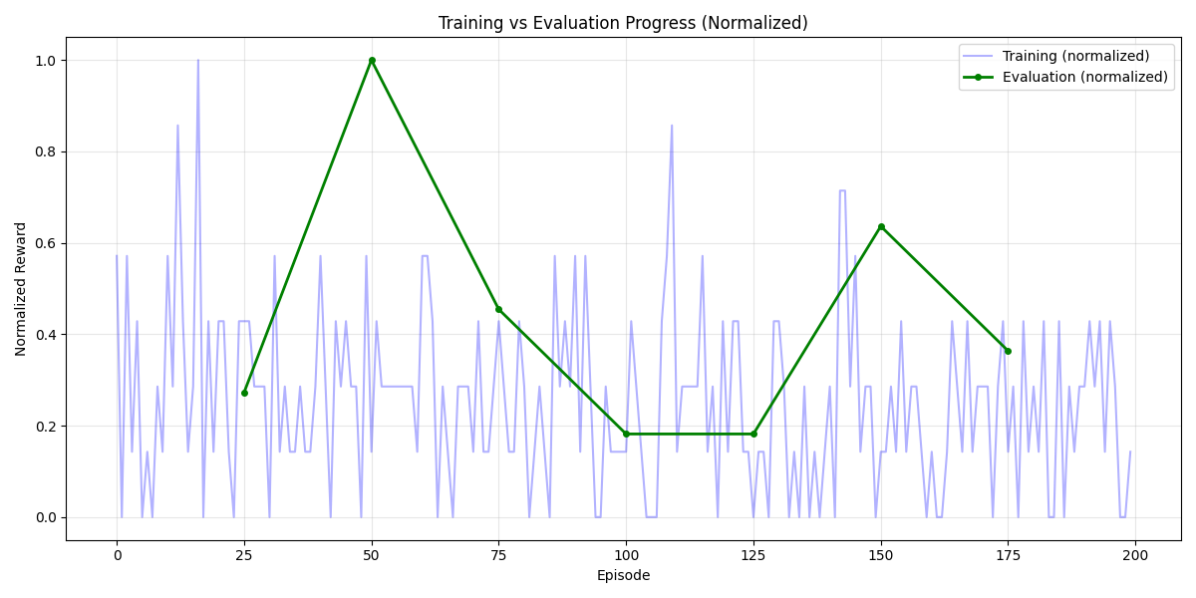
The comparison between training and evaluation rewards (normalized) revealed:
- Early Training: Evaluation performance peaked around episode 50
- Mid Training: Stable evaluation performance with some fluctuations
- Late Training: Gradual decline in evaluation performance
- Training-Evaluation Gap: Consistent gap suggesting some overfitting
Key Technical Insights
Frame Preprocessing Impact
The preprocessing pipeline significantly impacted learning:
- Grayscale conversion: Reduced computational complexity
- Frame stacking: Provided temporal information for movement detection
- Normalization: Improved neural network training stability
Experience Replay Benefits
Experience replay provided several advantages:
- Sample efficiency: Reused experiences multiple times
- Stability: Broke temporal correlations in sequential data
- Convergence: Improved learning stability and convergence
Target Network Stabilization
The target network mechanism:
- Reduced oscillations: Provided stable learning targets
- Improved convergence: Enhanced overall training stability
- Update frequency: 1000-step intervals proved effective
Comparative Analysis: Q-Learning vs Deep Q-Learning
Algorithm Complexity
- Q-Learning: Simple tabular approach, suitable for discrete low-dimensional spaces
- Deep Q-Learning: Complex neural network approach, handles high-dimensional continuous spaces
Sample Efficiency
- Q-Learning: Highly sample efficient due to direct table updates
- Deep Q-Learning: Less sample efficient due to neural network training requirements
Scalability
- Q-Learning: Limited to small state spaces (16 states in Frozen Lake)
- Deep Q-Learning: Scales to complex environments (210×160×3 Atari frames)

Performance Characteristics
- Q-Learning: Achieved 61% success rate with optimal hyperparameters
- Deep Q-Learning: Achieved meaningful performance on complex visual task
Conclusion:
This project explored reinforcement learning in two environments: FrozenLake and Atari Breakout. In the FrozenLake environment, Policy Iteration worked better than Q-Learning, with a higher success rate. Q-Learning was very sensitive to the choice of hyperparameters. The best results came when the learning rate was set to 0.5, the discount factor was high (0.95 or above), and the exploration rate started at 1.0. These settings helped the agent learn more effectively in a random environment.
In the second part, Deep Q-Learning was applied to the Atari Breakout game. The agent was able to learn useful strategies, showing that deep learning can handle complex environments. However, the training was sometimes unstable, and performance changed over time. Overall, this assignment showed how reinforcement learning can scale from simple tasks to harder ones, and how important it is to choose the right method and parameters for each problem.

